RAG prototype: a small, representative collection of your actual source code, API documentation, schemas, runbooks and tests. in this can i take real world data for infosys and also in future terms how can i secure these api keys passwords so what i will do it our system will only do modifications in the api files source codes and stuff and the human in the loop will get interacted as when the repairing is going on the agent connected to it will monitor and give a side panel containing to change or modify the particular key or crucial passwords so that it remains the privacy
Yes, you can use real-world Infosys-related information to build UMBRELLA's RAG prototype, but we need to distinguish publicly available engineering knowledge from Infosys's private internal systems.
Your second idea is also a good architectural direction: UMBRELLA should repair application code where authorized, while secrets remain outside the AI's visibility. A human-in-the-loop side panel can help operators review changes to configuration or credentials without exposing the actual secret values to the model.
I'd design these as two separate capabilities: a company-specific knowledge base and a secure remediation control plane.
1. Can you use Infosys data for RAG?
Public Infosys information — yes, with conditions
You can investigate publicly accessible technical articles, official engineering blogs, public documentation, public repositories, and published case studies. Follow the applicable licence and terms, respect copyright, and cite sources in your research paper.
This is useful for researching industry problems and building a prototype, but it will not reveal the private implementation of Infosys's internal backend systems.
Private Infosys source code, incidents or credentials — only with explicit authorization
Do not obtain proprietary repositories, internal incident logs, customer data or confidential runbooks through unauthorized access, leaked datasets or employee credentials.
If Infosys or an authorized partner provides a dataset, establish permitted uses, storage restrictions, retention periods, and whether publication or redistribution is allowed.
For actual repair experiments — use a controlled application
Public articles explain concepts; they usually don't contain the source code, expected behavior, tests and verified failure-to-fix history needed to repair a specific backend reliably.
Use an application you own or have permission to test, such as GrowSphere, and deliberately create reproducible failures. This provides evidence that your prototype can diagnose, propose a patch, test it and verify recovery.
My recommendation: use public Infosys materials as supplementary knowledge, but make GrowSphere—or another authorized test application—the primary executable test environment. Don't describe public Infosys material as Infosys production training data.
2. How UMBRELLA should protect API keys and passwords
Your idea of restricting modifications to source code and involving a human when sensitive configuration changes are needed is sensible. I would strengthen it with one rule:
The AI agent must never need to read or display the actual secret value to diagnose or repair a problem.
For example, if GrowSphere's database connection fails, UMBRELLA should be able to see that the database authentication failed without receiving the database password itself.
1. Monitoring and diagnostic agent
Receives sanitized logs, status codes, error types, metrics and service health.
2. RAG and remediation agents
Retrieve approved documentation, identify likely causes and propose code changes. Secret values are not placed in prompts or retrieved documents.
3. Deterministic policy and patch validator
Checks permitted file paths, rejects embedded credentials, validates the diff and enforces approvals.
4. Isolated testing and human approval
Run tests in a sandbox; display the proposed diff and test results. Require approval for sensitive or production-affecting actions.
5. Secret manager and controlled deployment
A separate authorized service handles secret references, rotation and deployment without exposing secret values to the LLM.
3. How should the actual code be written?
Application code should reference environment variables or a secret manager, rather than contain credentials directly.
For example, in a Python backend:

import os

DATABASE_URL = os.environ["DATABASE_URL"]
API_KEY = os.environ["EXTERNAL_API_KEY"]

The values are supplied by the deployment environment or secret manager. They should not be committed to Git, embedded in RAG documents, or sent to an LLM.
For local development, use a .env file that is excluded from version control, with a sanitized .env.example containing placeholder values. For production, prefer a dedicated secret manager and workload identity or short-lived credentials where supported.
For UMBRELLA, I would implement these controls:
- Secret detection: scan repository files, proposed patches, logs and retrieved content for credentials before they reach the model or are committed.
- Path restrictions: allow changes only to approved source and test directories by default. Configuration changes must follow a separate policy.
- Patch review: show the exact diff, affected files, explanation, tests and rollback plan before approval.
- Sandbox execution: test generated code with restricted permissions and no unnecessary access to production secrets.
- Audit trail: record who approved a change, which version was modified, which checks ran and whether recovery succeeded—never record the secret value.
- Least privilege: give each agent only the permissions it needs. The learning agent must not be able to grant itself additional access.
Restricting writes to API source files is a good starting point, but it is not sufficient by itself: source code can accidentally leak credentials, and even an API-file change can introduce a security vulnerability.
4. Your human-in-the-loop side panel
I would design the panel to distinguish ordinary code repairs from sensitive configuration operations.
UMBRELLA · Repair Console
Approval required
INCIDENT
Database authentication failure
Service: GrowSphere API · Status: Recovery not verified
Proposed code repair
Validate database configuration loading and improve connection error handling.
The proposed diff, automated test results and rollback plan would appear here.
Static checks passed (illustrative)
Sensitive configuration
DATABASE_URL
Secret manager reference · Value hidden
Protected
Suggested action: verify credential validity and connectivity. If rotation is needed, request a separate authorized rotation workflow.
The actual credential is never returned to the model or displayed in this panel.
Review diff
Approve action
Illustrative interface concept, not a connected or functioning repair console.
The actual workflow should work as follows:
- UMBRELLA detects a fault and proposes a repair.
- The console shows the diagnosis, evidence, proposed code diff and test results.
- If the issue involves credentials, the console identifies the secret by name or reference—not its value.
- An authorized operator can initiate a separate rotation or configuration-update workflow. The secret manager performs the sensitive operation.
- UMBRELLA verifies that the service recovers without ever reading the new secret value.
Avoid asking humans to paste passwords into the chat or side panel. Use the secret manager's authenticated interface or a tightly controlled backend operation instead.
5. What we should implement first
For your initial advanced RAG prototype, build these capabilities in this order:
- Ingest GrowSphere source code, API documentation, schemas, tests and approved runbooks.
- Add metadata, source citations, version tracking and access controls.
- Build secret redaction and repository scanning before connecting an LLM to repository content.
- Implement incident retrieval and evidence-grounded diagnosis.
- Generate proposed patches only in an isolated branch or workspace.
- Add deterministic patch validation, automated tests and human approval.
- Integrate a secret manager and controlled rotation only after the code-repair workflow is secure.
This gives UMBRELLA a defensible security architecture as well as a useful RAG system. The same design can later support other authorized company backends without mixing their source code, credentials or private incident histories.
so give me details to search and get from the perplexity on prompt what to say to retrieve the finest and best top quality information and code files and perfect realtime original data in a pdf format no matter how much big it is
For UMBRELLA, the best approach is to use Perplexity as a research and source-discovery assistant, then turn the verified findings into a curated RAG knowledge base. We want authoritative documentation, real open-source backend code, reproducible failure cases, security guidance, and evaluation datasets—not simply a massive PDF full of loosely related AI articles.
One important limitation: Perplexity cannot legitimately retrieve private Infosys source code, confidential production logs, or live credentials that aren't publicly authorized. Also, a PDF is excellent for research papers and documentation, but source code, structured logs, test cases, and repository history should usually be preserved in their native formats for RAG ingestion.
1. What you should collect
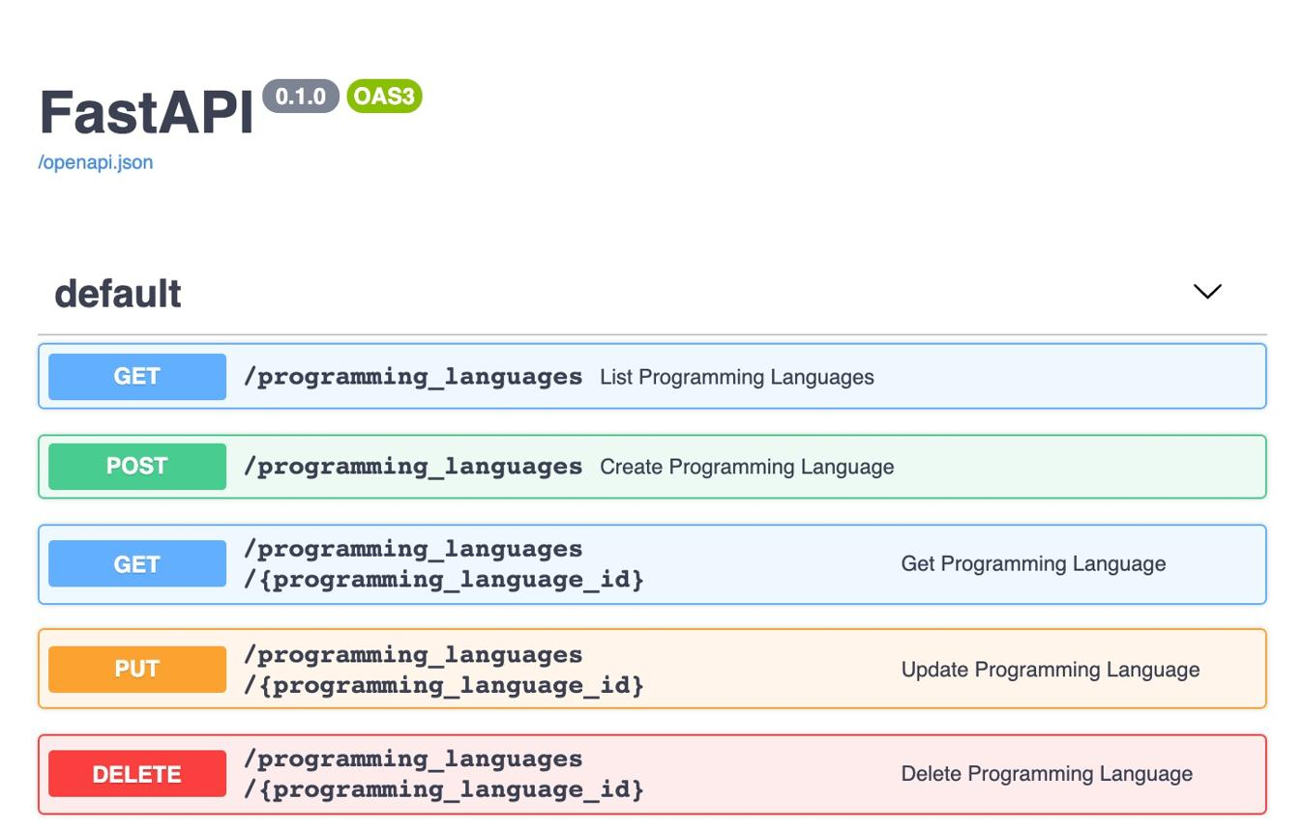
A. Backend architecture and source code
Find production-quality examples of API routing, middleware, authentication, database connection management, retries, timeouts, health checks, error handling, and graceful shutdown.
Preferred sources: official framework documentation and maintained, permissively licensed GitHub repositories.
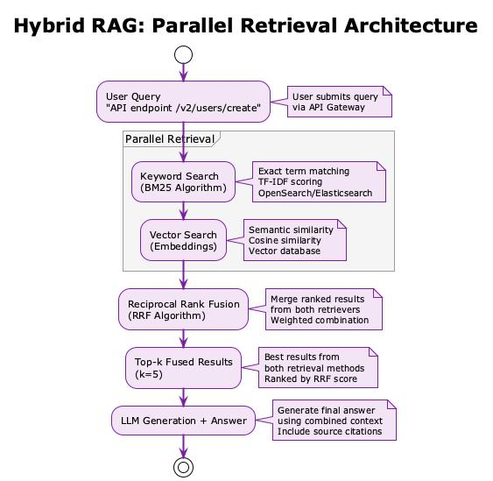
B. Advanced RAG engineering
Collect authoritative material on ingestion, parsing, chunking, embeddings, hybrid retrieval, reranking, metadata filters, source citations, versioning, access controls, and retrieval evaluation.
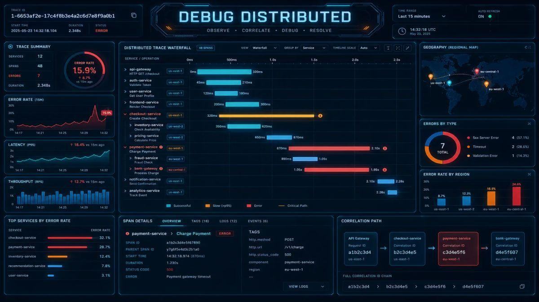
C. Real failure and incident data
Search for public incident postmortems, sanitized logs, benchmark fault scenarios, API traces, outage reports, and reproducible bugs with documented fixes.
A real incident report is not necessarily a machine-readable dataset; prefer cases with symptoms, root causes, remediation steps, and verified outcomes.
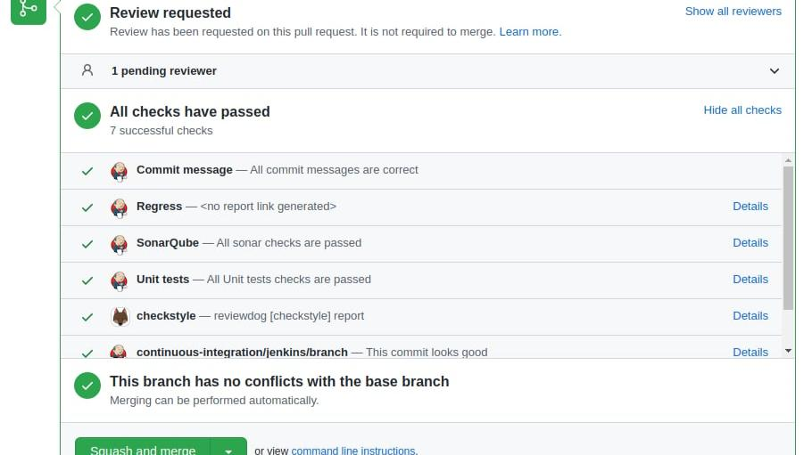
D. Code repair and self-healing research
Find reproducible software bugs, original buggy and fixed code, regression tests, automated repair benchmarks, fault-injection tools, and studies comparing repair strategies.
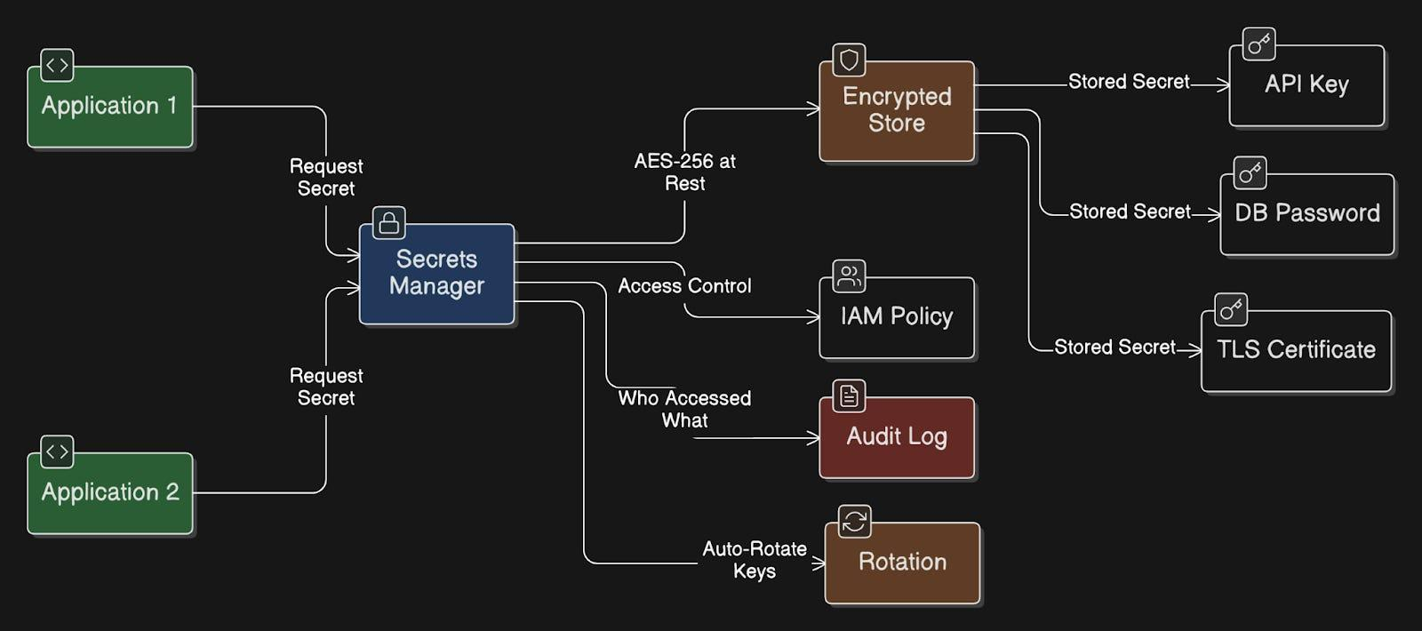
E. Secure autonomous remediation
Find guidance on secret management, least privilege, patch review, sandbox execution, policy enforcement, rollback, human approval, and auditability.
2. Master prompt for Perplexity
Copy this prompt into Perplexity's research-focused mode. It asks for a comprehensive, evidence-backed technical report that can become the foundation of your UMBRELLA research library.
Research Assignment: UMBRELLA — Production-Grade RAG, Backend Self-Healing, and Outcome-Aware Autonomous Remediation
Act as a senior software reliability researcher, backend architect, RAG engineer, application security specialist, and IEEE research assistant.
I am developing Project UMBRELLA: A Risk-Aware Multi-Agent Framework for Autonomous Fault Detection, Diagnosis, Remediation, and Self-Healing of Software Systems.
The initial deployment target is an application I own or am authorized to test, GrowSphere. The system will eventually include a shared advanced RAG knowledge system, five specialist agents, and a sixth Backend Evolution and Self-Learning Agent.
My objective is to build a reliable research-grade prototype and produce a technically rigorous, well-sourced engineering report that supports implementation and future experimental evaluation.
1. Research requirements
Conduct a comprehensive, source-driven investigation into:
- Production-grade RAG architectures for software engineering and backend troubleshooting.
- Real backend source code, API implementation patterns, error handling, dependency management, database connectivity, authentication, observability, and recovery.
- Real, publicly accessible software defects, failure scenarios, incident postmortems, bug-fix commits, regression tests, and remediation outcomes.
- Multi-agent systems for fault detection, diagnosis, root-cause analysis, repair planning, safe execution, and verification.
- Outcome-aware learning methods that improve recovery-action ranking using verified remediation results.
- Secure autonomous code repair, human-in-the-loop approval, sandboxing, policy enforcement, secret management, rollback, and audit logging.
- Reproducible datasets, benchmarks, evaluation protocols, and relevant academic research.
Prioritize original documentation, original research papers, maintained open-source repositories, official benchmark documentation, and reproducible experimental artifacts.
2. Required source quality
Prioritize sources in this order:
- Official project documentation and primary research publications.
- Original GitHub repositories and maintainers' technical documentation.
- Public benchmark repositories and reproducible datasets.
- Peer-reviewed IEEE, ACM, USENIX, and other relevant research.
- Official engineering postmortems and security advisories.
- High-quality secondary sources only when primary sources are unavailable.
For every important source, provide:
- Exact title and direct URL.
- Author, organization, or maintainer.
- Publication or release date, if available.
- Source type and whether it is primary or secondary.
- Relevant version, commit, or release identifier, if available.
- License and permitted reuse, when applicable.
- What specific engineering question the source answers.
- Limitations, missing evidence, and any uncertainty.
Verify that links resolve and that the material actually supports the associated claims. Never fabricate sources, code, benchmarks, experimental results, incident details, or citations. Explicitly label unverified or inaccessible material.
Prioritize currently maintained versions and recent research, while retaining older foundational papers when they remain technically relevant. Record the date on which the research was performed.
3. RAG engineering research
Investigate and compare:
- Repository ingestion and incremental updates.
- Parsing Python, JavaScript, TypeScript, SQL, YAML, JSON, Markdown, OpenAPI, and configuration files.
- Syntax-aware and semantic code chunking.
- Embedding models and vector search.
- Keyword/BM25 retrieval and hybrid search.
- Reranking and context selection.
- Metadata filters and repository/tenant isolation.
- Source citations, exact file paths, line ranges, and commit references.
- Dependency graphs and cross-file context.
- Retrieval freshness, duplicate detection, deletion handling, and version control.
- Prompt-injection defenses for untrusted repository files and retrieved documents.
- Retrieval evaluation, including Recall@k, MRR, nDCG, answer grounding, and citation correctness.
Recommend an implementable architecture for a Python/FastAPI backend, but compare alternatives objectively rather than selecting tools solely because they are popular.
Include official documentation and working source-code examples with license information. Explain which components are necessary for the first prototype and which should be postponed.
4. Real-world backend failure and repair datasets
Identify actual, publicly accessible datasets and repositories containing software defects or failure scenarios.
Investigate relevant resources such as SWE-bench, BugsInPy, Defects4J, and other suitable backend or software-repair benchmarks. Verify their current official repositories, scope, data formats, licenses, evaluation protocols, and limitations.
For each candidate dataset, report:
- Official name and repository URL.
- Supported programming languages and frameworks.
- Number and types of instances, verified from the primary source.
- Whether it contains original code, bug reports, patches, tests, logs, traces, or expected outcomes.
- Whether instances can be reproduced in a controlled environment.
- License and restrictions on redistribution.
- Relevance to API/backend self-healing.
- How it could be used in a reproducible experiment.
Distinguish real historical incidents from synthetic fault injection and benchmark-generated scenarios.
Do not claim that a dataset provides production telemetry or verified remediation outcomes unless its documentation establishes that fact.
5. Enterprise and Infosys-related material
Find public Infosys engineering publications, official technical articles, public case studies, public repositories, and publicly released research relevant to backend reliability, cloud operations, incident management, observability, software engineering, and AI-driven automation.
Clearly distinguish:
- Public Infosys-authored material.
- Third-party descriptions of Infosys projects.
- Independently maintained open-source examples.
- Confidential material that is not publicly available.
Do not attempt to obtain leaked data, private repositories, internal incident logs, customer records, credentials, or unauthorized access. Do not imply that public information represents Infosys's actual internal production systems.
Explain which public material is useful as general RAG knowledge and which material is insufficient for testing repairs on a particular backend.
6. UMBRELLA multi-agent architecture
Research evidence-backed designs for these specialist roles:
- Root Cause Intelligence.
- System Visualization / Digital Twin.
- Remediation Strategy.
- Autonomous Remediation and Execution.
- Reliability Orchestrator / Safety Guardian.
- Backend Evolution and Self-Learning Agent.
Treat RAG as a shared knowledge capability rather than automatically counting it as another specialist agent.
Describe agent contracts, inputs, outputs, evidence requirements, confidence and uncertainty, communication boundaries, audit records, failure handling, and integration points.
The sixth agent should learn from independently verified remediation outcomes and improve the ranking of actions that the deterministic policy engine already permits. It must not be able to grant itself permissions or bypass safety controls.
Identify existing work that is similar to this architecture and clearly separate established techniques from possible research contributions.
7. Secure code repair and secret management
Research and document a defense-in-depth design covering:
- Environment variables and dedicated secret managers.
- Secret scanning and redaction before model ingestion.
- Least-privilege credentials and workload identity.
- Repository and file-path allowlists.
- Static analysis, tests, dependency checks, and patch validation.
- Sandboxed execution with restricted network and filesystem access.
- Human review and approval of sensitive changes.
- Controlled credential rotation without returning secret values to the LLM.
- Health checks, post-repair verification, rollback, and escalation.
- Tamper-resistant audit logging without recording credentials.
- Protection against prompt injection and malicious instructions in repository content.
- Separation of tenants, projects, source code, incident records, and permissions.
Provide a threat model, attack scenarios, mitigations, and testable acceptance criteria.
8. Research contribution and novelty audit
Investigate the closest existing approaches to:
- Learning from verified remediation outcomes.
- Risk-adjusted recovery-action ranking.
- Verification-aware feedback loops.
- Safe autonomous software repair.
- Human-approved execution and rollback.
- Generalization to unseen backend failure scenarios.
Build a comparison matrix showing each source's actual methods, feedback mechanism, safety constraints, evaluation metrics, limitations, and evidence.
Do not declare a research gap merely because a paper does not use the same terminology as UMBRELLA. Identify the closest conceptual equivalents.
Propose no more than three candidate contributions, rank them by evidence of novelty, feasibility, implementation cost, and experimental testability, and specify what further literature search is needed before making any novelty claim.
9. Experimental design
Design a reproducible prototype evaluation comparing:
- Fixed-priority recovery-action selection.
- RAG/LLM-based recommendations without outcome adaptation.
- Outcome-aware ranking using verified results.
- Ablations that isolate risk adjustment and outcome verification.
Specify suitable controlled backend fault scenarios, baseline requirements, train/test separation, repeated trials, metrics, statistical analysis, reproducibility artifacts, and threats to validity.
Consider remediation success, time to verified recovery, failed actions, ranking quality, regressions, policy violations, and performance on unseen scenarios.
Do not invent results or predetermined improvements. Separate proposed hypotheses from experimentally established findings.
10. Deliverable: comprehensive engineering research report
Create a detailed, structured report with:
- Executive summary.
- Scope, methodology, search strategy, and source-quality criteria.
- Annotated bibliography.
- RAG architecture and implementation recommendations.
- Public datasets and benchmark comparison.
- Backend source-code and repair-resource catalog.
- Infosys public-source research section.
- Six-agent UMBRELLA architecture.
- Security and secret-management design.
- Research-gap and novelty comparison matrix.
- Experimental protocol and metrics.
- Implementation roadmap and prioritized tasks.
- Risks, limitations, and unresolved questions.
- Full reference list with direct links.
- Appendices containing schemas, interface contracts, code snippets, commands, configuration examples, and reproducible setup instructions where verified.
Use clear headings, tables, diagrams when supported, and code blocks. Preserve exact source URLs and citations. Mark all code as illustrative or tested, as appropriate.
Make the report as comprehensive as reasonably possible without padding it with irrelevant material. Organize it by implementation relevance, not just publication date.
If PDF export is available, export the report as a searchable PDF with a table of contents, clickable references, readable code formatting, and page numbers. If the report exceeds one document's practical limits, divide it into clearly numbered volumes and provide a master index. Do not silently omit material to fit a length limit.
Also provide a machine-readable source manifest, preferably CSV or JSON, containing the title, URL, source type, date, license, topic, and verification status of each source.
Finally, distinguish clearly between verified facts, recommendations, hypotheses, and unanswered questions. Do not represent the report as exhaustive if the available search coverage is incomplete.
3. Run these targeted searches separately
Do not rely on one giant query. Run each of these as a separate Perplexity research task so you can verify the findings in depth.
Prompt 1 — Real backend code and repair datasets
Priority: highest for the implementation and experiments.
Find original repositories, real bug-fix commits, failing tests, regression tests, and reproducible backend defects. Investigate SWE-bench, BugsInPy, Defects4J, and relevant API or cloud reliability benchmarks. Include official links, language, framework, license, data format, reproduction instructions, and whether the benchmark supports backend self-healing research. Return a ranked shortlist and explain which datasets can actually be executed in a controlled environment.
Prompt 2 — Advanced RAG architecture and code
Research production-grade RAG for codebases. Find official documentation and maintained repositories for syntax-aware code parsing, hybrid retrieval, embeddings, reranking, metadata filtering, repository versioning, citations, and evaluation. Provide working implementation references and licensed examples, compare alternative stacks for a Python/FastAPI system, and recommend the minimum viable architecture for a secure research prototype. Distinguish runnable code from pseudocode.
Prompt 3 — Infosys public research and industry practices
Search official Infosys publications, engineering articles, public case studies, public repositories, and research on software reliability, backend engineering, AIOps, observability, incident response, and AI-assisted repair. Give direct source links and dates, distinguish Infosys-authored material from third-party coverage, and identify permitted public knowledge suitable for a RAG corpus. Do not infer internal architecture or claim access to private production data.
Prompt 4 — Real incidents and root-cause evidence
Find publicly documented software outages and incidents that include a clear timeline, symptoms, root cause, corrective actions, and post-incident verification. Prefer official engineering postmortems and public incident repositories. Extract each case into a structured table and identify which cases provide enough evidence to create reproducible test scenarios. Do not invent missing logs or claim a documented fix was successful unless the source supports that conclusion.
Prompt 5 — Secure autonomous repair
Find official technical guidance and research on secret management, secure AI coding agents, patch validation, sandboxed execution, human approval, least privilege, audit logs, rollback, and prompt-injection defenses. Prioritize official cloud-provider security documentation and maintained security tools. Produce a threat model, architecture, implementation references, and measurable security acceptance tests for an autonomous FastAPI backend repair system.
Prompt 6 — IEEE research novelty
Conduct a focused literature review of outcome-aware software remediation, verified repair feedback, risk-aware recovery-action selection, and self-healing systems. Compare the closest existing papers by their learning signals, action-selection methods, safety constraints, experimental baselines, and limitations. Identify candidate gaps only where evidence supports them, provide exact citations, and propose a falsifiable hypothesis with an implementable experiment. Do not claim novelty without checking closely related approaches.
4. Which sources should you prioritize?
These are good starting points for discovering real, reproducible engineering material. Open the original source, inspect its contents and licence, and follow the links to the actual code or documentation.
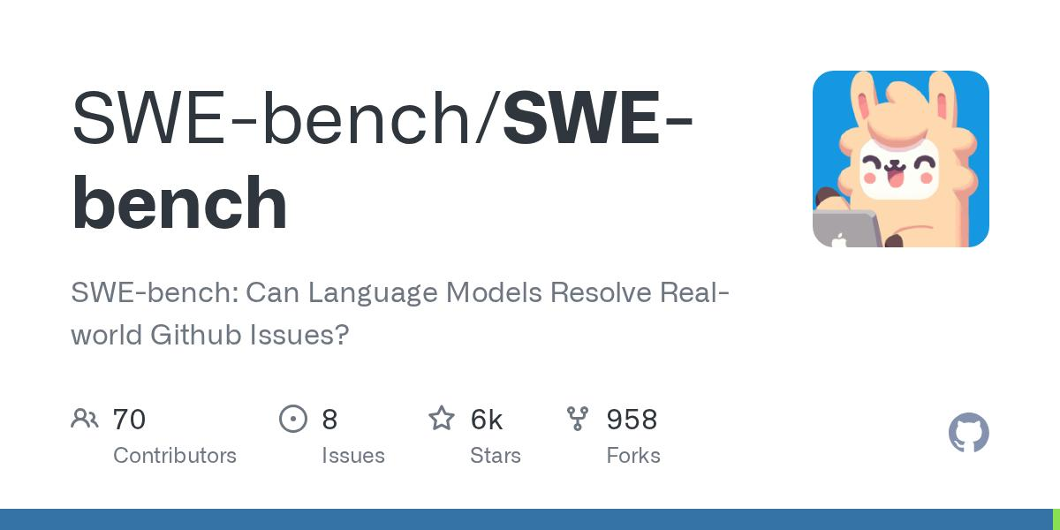
SWE-bench
Benchmark for evaluating whether systems can resolve real software issues. Useful for patch-generation and issue-resolution experiments, but it is not a dedicated production telemetry dataset.
Official repository
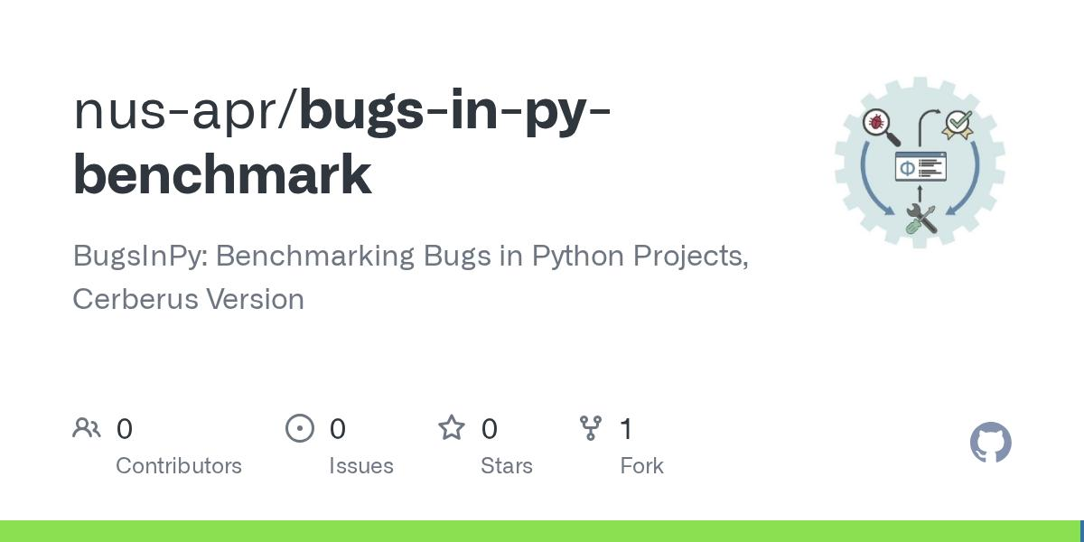
BugsInPy
Useful for Python bug reproduction and repair experiments with real defects and associated test information.
Official repository
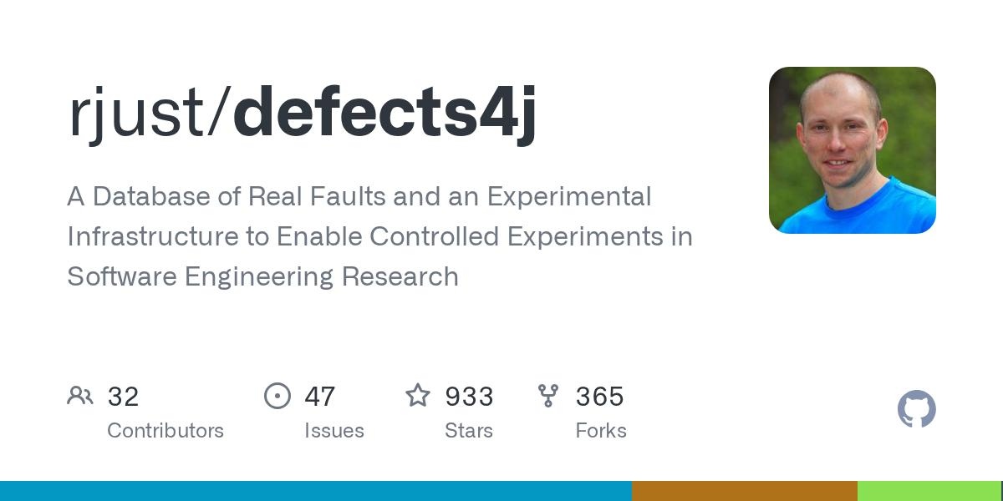
Defects4J
A benchmark of real Java defects, useful for testing reproducible bug-fixing methods even though it is not specifically a backend API dataset.
Official repository
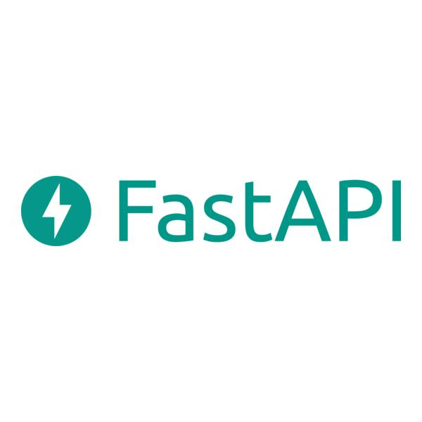
FastAPI documentation
Use the official documentation for API behavior, dependency injection, security, validation, testing, and application lifecycle patterns.
Official documentation
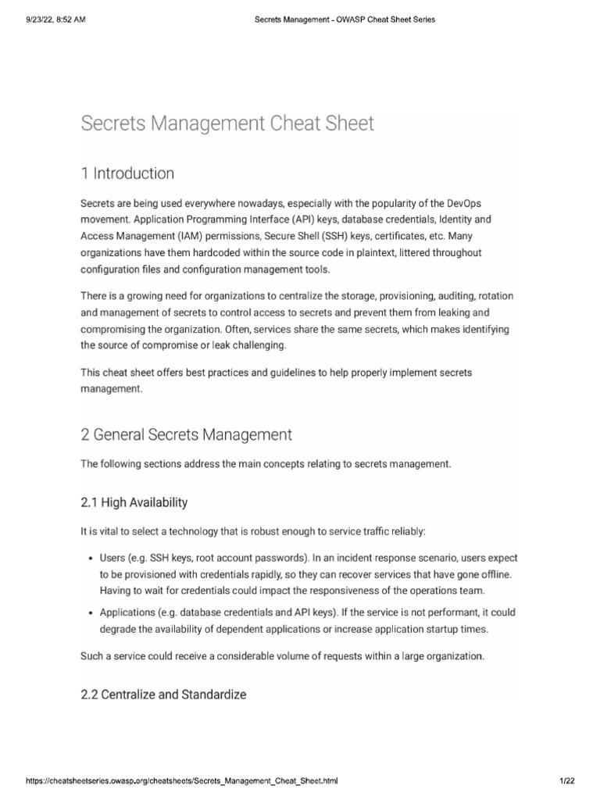
OWASP
Consult its official security guidance for secrets handling, secure development, logging, and application security controls.
Official website
5. How to get a useful PDF from Perplexity
- Run the master prompt in its research mode, then run the six focused prompts separately.
- Ask it to cite primary sources inline and provide a reference list with direct links.
- Generate the final report from the verified findings, rather than concatenating every search result into one enormous document.
- Use Perplexity's available export, print, or save-to-PDF options. Interface options can vary, so check which are available in your account.
- If the report is too long, produce separate volumes: RAG engineering, datasets and backend repairs, security architecture, and research novelty/experiments.
- Preserve the original code repositories and datasets separately. Do not use a PDF as the only copy of source code.
What “high quality” should mean
A report containing 500 pages of loosely related material is not necessarily better than 100 pages of verified documentation and reproducible code. For each candidate source, check:
- Does the link lead to the original source?
- Is the repository maintained, and is the code actually runnable?
- Is its licence compatible with your intended use?
- Does the dataset contain the fields and outcomes you need?
- Can the relevant experiment be reproduced?
- Is the information relevant to the GrowSphere backend and UMBRELLA's specific research question?
My recommendation: start with Prompts 1, 2 and 6. They establish the repair data, RAG implementation, and research contribution. Then use Prompts 3–5 to enrich the knowledge base and security design. This gives you a curated foundation for the first working RAG agent without waiting for an enormous document to be completed.
but i need original stuff of infosys right
Yes—if your goal is to make UMBRELLA work specifically with Infosys systems, then Infosys-specific material is more useful than generic backend examples. But there is one important distinction:
- Original Infosys material: documents, technical publications, code, or datasets actually produced or released by Infosys.
- Infosys-specific production data: internal source code, API specifications, incident logs, architecture diagrams, runbooks, and verified repair histories from a particular Infosys system.
The first category may be publicly accessible. The second generally requires authorization from Infosys or the relevant system owner. Public articles about Infosys do not give you access to its internal backend.
If you intend to repair a real Infosys application, your RAG knowledge base should ideally combine authorized Infosys project documentation and source code with carefully selected public technical references. Otherwise, your prototype can learn general repair techniques, but it cannot reliably know how a particular Infosys backend is configured or supposed to behave.
2. Where to get original Infosys material
I found several genuine, publicly accessible starting points.
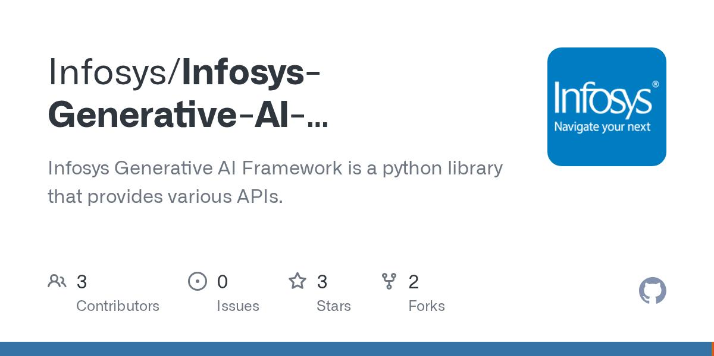
Infosys Agentic Foundry
An Infosys-published open-source framework for building and deploying AI agents. Useful for understanding enterprise agent architecture, orchestration, and observability—not evidence of Infosys's internal production backends.

GitHub
Source code and documentation
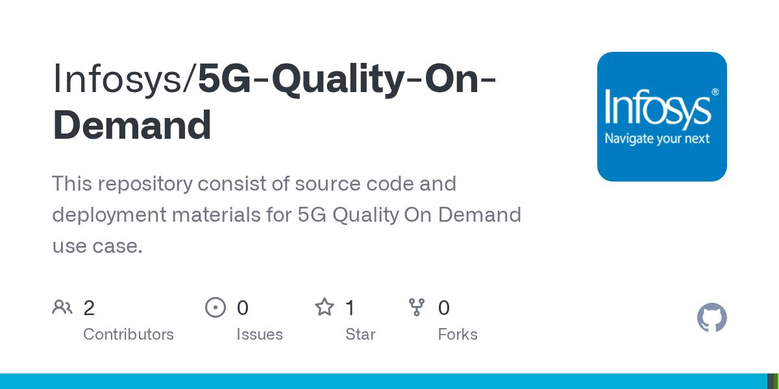
Infosys Server-Patching-Tool
A public Python repository describing server patch management and execution-status tracking. This is especially relevant to remediation workflows, although server patching is not the same as AI-driven API repair.
GitHub
Source repository
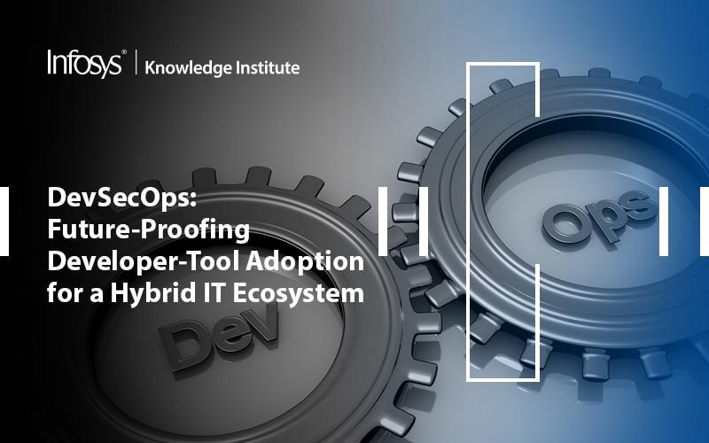
Infosys DevSecOps research
Official technical articles and white papers about DevOps, infrastructure as code, and platform engineering. Use these to enrich operational and security knowledge.

Infosys
Infosys technical publications
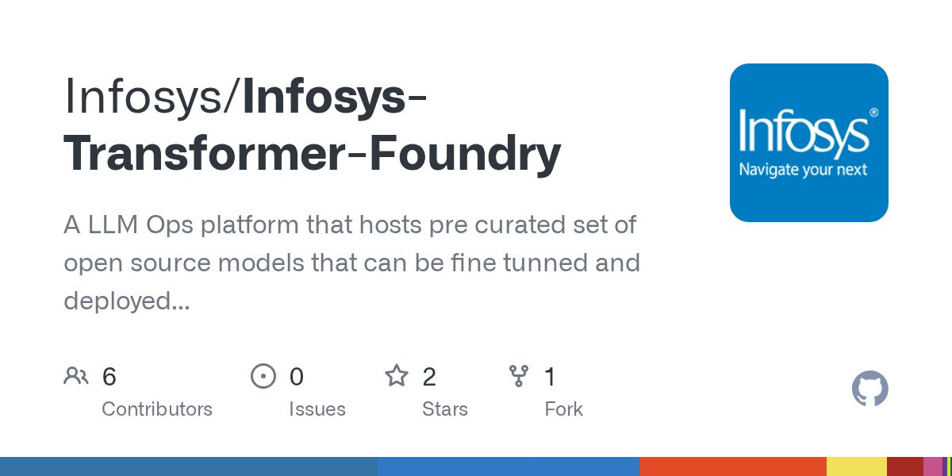
Infosys engineering articles and open-source projects
Browse the official GitHub organization and Infosys's published engineering insights for additional original materials. Each repository has to be checked individually for relevance and licensing.
GitHub
+1
All public Infosys repositories · Official Infosys blog
3. The exact Perplexity prompt for original Infosys sources
Conduct a source-verified research investigation specifically into original, publicly released Infosys technical materials for Project UMBRELLA, an AI-driven backend diagnosis, code repair, and self-healing framework.
I am not looking for generic backend tutorials or articles that merely mention Infosys. I want original material published or maintained by Infosys itself.
Search these source categories:
- Official Infosys GitHub repositories, including source code, README files, technical documentation, examples, tests, configuration templates, release notes, and issue/commit history.
- Official Infosys engineering blogs, technical white papers, research publications, architecture documents, and developer resources.
- Public Infosys tools related to DevOps, DevSecOps, server patching, observability, application modernization, API management, agentic AI, incident management, and automated remediation.
- Publicly released Infosys case studies that describe actual software reliability problems, engineering practices, operational failures, or verified improvements.
- Original Infosys-authored publications available through official websites, GitHub, conference proceedings, or institutional publication records.
For every result, provide:
- Exact title and direct source URL.
- Evidence that Infosys authored, published, or maintains it.
- Repository owner and current status, where applicable.
- Programming language and technical scope.
- Source-code files and documentation files that are publicly available.
- Release date or last update, if verifiable.
- License and restrictions on reuse or redistribution.
- Whether the source contains actual code, architecture descriptions, test cases, failure data, or only general guidance.
- Specific relevance to RAG, backend repair, incident diagnosis, autonomous remediation, or secure code changes.
- Limitations and information that the source does not disclose.
Prioritize original source repositories over secondary articles. Follow links to actual files instead of returning only search-result summaries.
Separate the findings into:
A. Original Infosys open-source code.
B. Official Infosys engineering and research publications.
C. Public Infosys case studies.
D. Third-party descriptions of Infosys work, clearly marked as secondary sources.
Do not provide leaked, confidential, private, or unauthorized Infosys code, internal production logs, customer information, credentials, or internal runbooks. Do not imply that public materials represent Infosys's entire internal technology stack.
Finally, rank the ten most relevant verified sources for building an authorized prototype of an AI backend self-healing system. Explain what each source contributes, and provide a downloadable or printable research report with a linked reference list if export is available.
4. One thing I need to clarify
When you say you want to repair Infosys's backend, which of these describes your actual objective?
I want original public Infosys code and documentation to build and test UMBRELLA.
I have, or expect to obtain, authorization and access to a particular Infosys project or backend.
I want to research how UMBRELLA could work in Infosys-like enterprise systems, without accessing their internal backend.
The distinction matters because public Infosys code can help you build a system inspired by real enterprise engineering, but only authorized, system-specific data can make the RAG knowledge base accurately repair a particular Infosys backend.
My objective for Infosys-specific data is: use original public Infosys code and documentation to build and test UMBRELLA. Recommend the appropriate source acquisition, permissions, RAG ingestion, and evaluation strategy.
1. Recommended source acquisition strategy
For your first UMBRELLA prototype, I would acquire two original Infosys repositories and use them for different purposes.
1. Infosys Agentic Foundry
Architecture reference
The public repository contains agent orchestration, backend and frontend components, documentation, evaluation, security-related capabilities and observability. Its README describes a FastAPI backend, agent workflows, feedback learning and tool execution.
GitHub
+1
Open original repository
What to acquire
- Architecture and design documentation.
- Agent orchestration and workflow implementation.
- Evaluation and validation modules.
- Backend API implementation and tests.
- Security, vault and observability documentation.
Use this to understand enterprise agent-system patterns. Avoid treating its agent framework as evidence that your self-healing research contribution is novel.
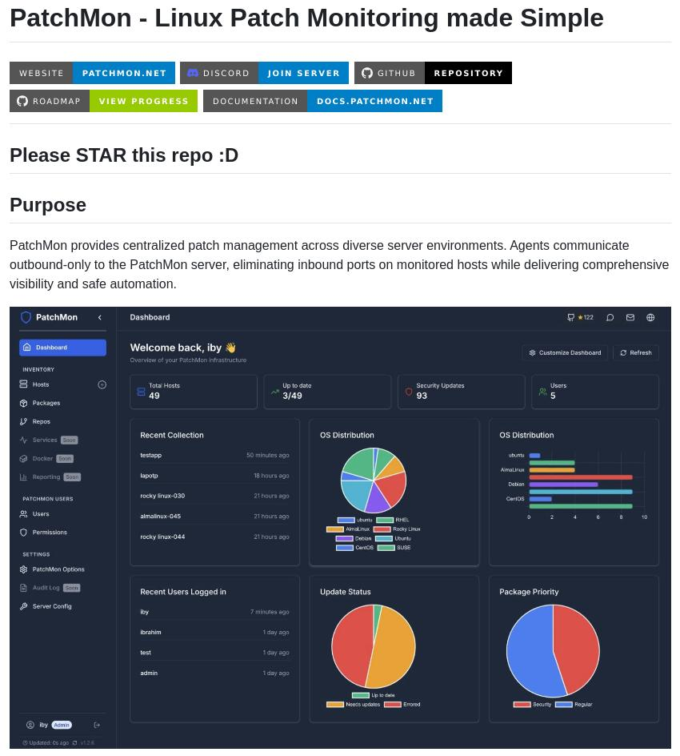
2. Infosys Server-Patching-Tool
Remediation reference
This public repository describes a patch-management workflow involving a Django portal, FastAPI endpoints, Ansible scripts and AWX orchestration, with execution-status tracking.
GitHub
Open original repository
What to acquire
- API endpoint source and configuration patterns.
- Workflow and orchestration scripts.
- Execution-status tracking and database models.
- Available tests and setup instructions.
- Documented patching procedures and error-handling patterns.
This is particularly relevant to UMBRELLA's controlled remediation and execution layer, but server patching is not equivalent to autonomous application-code repair.
Licensing check: Before using or redistributing any code, inspect the exact repository's LICENSE file and relevant third-party dependency licences. Public availability alone does not grant unrestricted reuse. Also preserve the original repository URL, commit SHA, retrieval date and licence record for every version you ingest.
2. Download the original material without losing provenance
Clone the repositories locally rather than asking Perplexity to reproduce their source code. That preserves the real files, directory structure and Git history.
mkdir infosys-public-sources
cd infosys-public-sources

git clone https://github.com/Infosys/Infosys-Agentic-Foundry.git
git clone https://github.com/Infosys/Server-Patching-Tool.git
For each repository, record the exact revision you used:
git -C Infosys-Agentic-Foundry rev-parse HEAD
git -C Server-Patching-Tool rev-parse HEAD
Also record the retrieval date and inspect the LICENSE file. Pinning the commit matters because public repositories change over time.
Do not ingest the entire repository blindly. First inspect its structure and identify relevant files. Exclude generated builds, vendored libraries, dependency caches, compiled files, secrets, and unrelated frontend assets unless they are required for your research question.
3. Build a source manifest for the RAG pipeline
Every ingested file should have traceable metadata. This is especially important when the source belongs to a third-party company.
A practical record could look like this:

{
"source_id": "infosys-agentic-foundry",
"source_type": "public_source_repository",
"repository_url": "https://github.com/Infosys/Infosys-Agentic-Foundry",
"commit_sha": "<record_actual_commit_sha>",
"retrieved_at": "<record_retrieval_date>",
"license_status": "pending_verification",
"file_path": "docs/<actual-file-path>",
"file_type": "markdown",
"content_hash": "<sha256-of-ingested-content>",
"topic": "agent_orchestration",
"trust_level": "external_reference",
"ingestion_status": "pending"
}
This is a schema example, not a claim that a particular file has already been ingested. Generate one record per file or code chunk, and retain the repository and file path in every retrieval result.
I recommend keeping three separate knowledge namespaces:
- infosys_public_reference — original Infosys public materials.
- umbrella_research — papers, benchmarks and independently sourced technical references.
- growsphere_authorized — your own application's source code, documentation and incident evidence.
These namespaces should not be mixed without provenance and access controls. In particular, external Infosys code must never be treated as if it were GrowSphere's source code.
4. How to transform the material into advanced RAG
Use this ingestion sequence:
1. Repository snapshot
Pin commit; record provenance and licence
2. File classification
Identify code, documentation, tests, schemas and configuration
3. Secure preprocessing
Detect secrets; exclude generated or unauthorized content
4. Structure-aware parsing
Keep functions, classes, routes, tests and relevant dependencies together
5. Chunking and indexing
Generate embeddings; index text and code with metadata
6. Hybrid retrieval
Combine keyword search, vector search and reranking
7. Evidence-grounded answer
Return exact source, file path, revision and relevant code
8. Evaluation
Test retrieval quality, citation accuracy and security
For source code, avoid arbitrary fixed-size text chunks where possible. Keep complete functions or classes, their file paths, imports and nearby tests. For large modules, split at meaningful syntax boundaries and retain parent/child relationships.
For PDF research papers and documentation, use a separate parser pipeline that preserves headings, tables, code blocks, page numbers and citations.
5. How to evaluate the RAG system using original Infosys code
The purpose of using these repositories should be to evaluate whether UMBRELLA can retrieve the right evidence—not to assume that it can repair the repositories successfully just because it indexed them.
Create a small evaluation set of questions with known source locations.
Test | Example question | What to measure
API retrieval | Where is a particular endpoint defined? | Recall@k, exact file-path accuracy
Workflow tracing | Which components trigger and track a patching job? | Evidence coverage and citation correctness
Failure handling | What happens if the orchestration request fails? | Relevant code/test retrieval and answer grounding
Security | Where are credentials referenced, and how are they protected? | Correct security evidence without secret exposure
Version awareness | Does the answer cite the pinned revision? | Provenance and version correctness
Unsupported question | Is a private internal implementation detail documented publicly? | Correctly state that evidence is unavailable
Have a human inspect the reference answers and relevant source lines. Keep evaluation questions separate from any examples used to tune prompts or ranking. Do not report RAG performance numbers until you have run the tests.
6. What permissions do you need?
For these public repositories, follow their licences and terms of use. You do not need access to Infosys internal systems simply to study publicly released code. However:
- Keep copyright and licence notices when required.
- Check whether your planned redistribution, modification and publication are permitted.
- Do not upload the source to an external LLM provider unless the applicable licence, organizational policies and provider terms permit your intended use.
- Do not infer that the repositories' public status authorizes testing against Infosys infrastructure.
- Do not describe the repositories as proprietary internal Infosys production code or claim that they contain internal operational incidents unless the evidence establishes that.
For your IEEE paper, cite the original repositories and describe exactly how you used them—as architecture references, retrieval corpus, or experimental subjects.
7. The important limitation for your research
These repositories can give you real, original Infosys code to analyze. But they are not, by themselves, a complete dataset for training or evaluating a backend self-healing agent.
To test actual repair capability, you still need reproducible failure cases, expected behavior, tests, candidate repair actions and independently verified outcomes. If the Infosys repositories don't supply those, you can construct controlled fault scenarios in a separate local fork, respecting the licence and documenting every modification.
For Agent 6, maintain your own experimental outcome records rather than assuming the source repositories contain verified repair histories.
My recommendation for the first implementation
Start with Infosys Agentic Foundry as the architecture and agent-orchestration reference, then inspect Server-Patching-Tool for its remediation workflow and API patterns. Ingest a carefully selected set of files from both into the public-reference namespace, build the retrieval evaluation set, and confirm that every answer links back to the exact source revision.
Once that works, connect RAG to your own authorized test backend. That is the point where UMBRELLA can begin demonstrating whether its recommendations actually improve diagnosis and repair.
so first i will give all these three repos to gemini in my antigravity and tell it to filter out the need only stuff and make the data clean first and then go with next step as the data which will be cleaned and will be stored then we will make a new data file for 6th as on our own for demo and practical scenarios
Yes — this is a sensible starting workflow for Project UMBRELLA, with one important adjustment: don’t ask Gemini in Antigravity to clean all three repositories and overwrite the originals. Have it create a curated, traceable dataset in a separate directory, preserving the original repositories unchanged.
Your plan should produce two distinct knowledge assets:
- Public-source reference dataset — relevant code, documentation, workflows, and tests extracted from the three repositories.
- UMBRELLA Agent 6 dataset — your own structured demo scenarios and verified remediation outcomes, which will eventually support outcome-aware learning.
Keep these separate so you can distinguish third-party reference material from your original experimental data.
Recommended workflow
Phase 1 — Acquire and preserve the three repositories
Keep the original repository snapshots, record their commit SHAs, and inspect each repository’s license before reuse.
Phase 2 — Curate using Gemini in Antigravity
Extract only relevant documentation, source files, configuration examples, tests, API definitions, and recovery workflows. Scan for secrets and remove irrelevant generated files.
Phase 3 — Store the clean reference data
Build a searchable corpus with file paths, repository names, commit SHAs, licenses, content hashes, and source citations. This becomes the knowledge base for your RAG system.
Phase 4 — Create your original Agent 6 dataset
Define controlled failure scenarios, candidate recovery actions, risk levels, verification tests, and observed outcomes. Use these records to evaluate whether Agent 6 improves its recovery-action rankings.
Phase 5 — Evaluate before integrating
Test retrieval accuracy, source citations, scenario coverage, remediation success, unsafe-action rate, and rollback behavior before connecting the agents.
1. Give Gemini this prompt first
Use this as your initial Antigravity task. It tells Gemini to curate the repositories without prematurely building the RAG pipeline or inventing training data.
Task: Curate Public Repository Data for Project UMBRELLA
Project context
I am developing Project UMBRELLA: A Risk-Aware Multi-Agent Framework for Autonomous Fault Detection, Diagnosis, Remediation, and Self-Healing of Software Systems.
My immediate objective is to prepare a clean, traceable reference dataset from three supplied public repositories. This dataset will later be ingested into our RAG knowledge base.
Your responsibilities
1. Inspect all three repositories
- Identify each repository's purpose, architecture, language, framework, and relevant modules.
- Inspect its LICENSE file and note any license ambiguity or third-party licensing requirements.
- Record the exact repository URL and current commit SHA.
- Do not assume that every file is authorized for unrestricted reuse merely because the repository is public.
2. Select relevant material
Prioritize material related to:
- Agent orchestration and multi-agent workflows
- API architecture, endpoints, and service integrations
- Monitoring, telemetry, logs, and incident handling
- Root-cause analysis and fault diagnosis
- Recovery, remediation, patching, and rollback workflows
- Tests, validation, error handling, and reliability
- Authentication, authorization, secrets management, sandboxing, and audit trails
- Evaluation, feedback loops, and outcome verification
- Configuration and dependency information necessary to understand the selected code
Exclude irrelevant generated builds, compiled artifacts, dependency caches, vendored libraries unless specifically needed and permitted, duplicate files, large binaries, and unrelated frontend assets.
Do not delete or modify the original repositories.
3. Security and quality checks
- Scan selected material for API keys, tokens, passwords, private keys, credentials, and other sensitive information.
- Never copy exposed secrets into the curated output. Quarantine the affected file or redact it in a separate derivative copy, recording the action.
- Do not execute repository scripts or install dependencies without inspecting them first.
- Identify obsolete, incomplete, duplicated, or context-dependent code.
- Do not silently rewrite source code or invent missing documentation.
- Preserve original file paths and source attribution.
4. Create a separate curated output
Create a new directory named umbrella-curated-reference/ containing:
- manifest.json: repository URL, commit SHA, retrieval date, license review status, source path, file type, content hash, selection reason, and processing status.
- documentation/: selected Markdown and other relevant documentation.
- source_code/: selected source files, preserving their original relative paths where practical.
- tests_and_examples/: relevant tests, API examples, and reproducible examples.
- architecture/: extracted architecture descriptions and workflow notes, clearly labelled as derived summaries.
- security_review.md: findings, exclusions, unresolved license questions, and secret-scan status.
- curation_report.md: what was selected, excluded, why it matters to UMBRELLA, and known limitations.
Maintain a mapping from every curated file to its original repository, path, and commit. Preserve applicable license and copyright notices.
5. Prepare for future RAG ingestion
Recommend appropriate parsing and chunking methods for each file type. For source code, preserve function/class boundaries, imports, filenames, and relevant tests. For documentation, preserve headings and section relationships.
Identify useful metadata fields for hybrid keyword/vector retrieval and source citations.
Do not create embeddings or build the complete RAG pipeline yet.
6. Strict scope boundaries
- Do not create Agent 6 training records in this task.
- Do not invent remediation outcomes or claim that code has been tested when it has not.
- Do not modify the original repositories.
- Do not connect to or test against any third-party production infrastructure.
- Do not build or deploy autonomous remediation functionality yet.
Deliverables
Produce the curated directory, a manifest, a security and licensing review, and a curation report.
At the end, summarize:
- Files selected and excluded.
- Files requiring manual review.
- License and security issues.
- Whether the curated output is ready for RAG ingestion.
- The recommended next step.
If a file cannot be processed safely or its license is unclear, flag it rather than guessing.
2. How to structure your Agent 6 data
Once the reference corpus is clean, create a separate dataset from your own controlled experiments. Don’t treat repository documentation as proof that a recovery action succeeded.
For example, a scenario record could look like this:
Illustrative example only — not an actual experiment result.
{
"scenario_id": "UMBRELLA-API-001",
"scenario": "API health-check endpoint returns HTTP 503",
"environment": "isolated_test_container",
"observed_signals": {
"status_code": 503,
"consecutive_failures": 5
},
"diagnosis": {
"hypothesis": "dependency unavailable",
"confidence": 0.82
},
"candidate_actions": [
{
"action": "check_dependency_health",
"risk": "low",
"approved": true
},
{
"action": "restart_service",
"risk": "medium",
"approved": false
}
],
"selected_action": "check_dependency_health",
"verification": {
"test_executed": false,
"recovery_verified": false
},
"outcome": "pending",
"rollback_required": null
}
The confidence value and signals above are placeholders. Your actual experiment should populate them from measured observations.
For Agent 6, the most important data is the verified outcome: which approved action was attempted, whether it worked, how long recovery took, whether regressions occurred, and what the verification tests reported. Failed and inconclusive attempts should also be retained.
3. Keep these datasets separate
Dataset | Purpose | Storage role
Public repository reference | Explain code, patterns, workflows, and architecture | RAG / vector index plus source manifest
Your controlled scenarios | Reproduce faults and compare candidate actions | Versioned JSONL or relational experiment store
Verified remediation history | Learn which approved actions work under which conditions | Structured outcome store, optionally retrieved as context
Live telemetry | Supply current incident evidence | Logs, metrics, traces, and event store
Important: RAG retrieval alone does not make Agent 6 learn. You need a defined update or ranking mechanism that uses verified outcomes, with the same safety checks applied before and after adaptation.
My recommendation is to finish the curated reference dataset first, validate it against a small set of questions, then build the initial RAG pipeline. After that, create 10–20 controlled scenarios and establish baseline results before implementing the outcome-aware adaptation logic. This gives you a more defensible research experiment than creating a large collection of unverified synthetic records.
okay so first will get those 3 repos and then i will prompt antigravity to extract the important and needy info and then save it in a pdf another separate and then i will make the rag advanced production grade and train the data on it and then i will start preparing rest 4 agents to connect with the rag once this architecture works and starts giving proper answers then will move to 6th the main software learning agent
Your sequence is broadly correct for Project UMBRELLA. I would make three adjustments to ensure the architecture is research-ready, maintainable, and safe: don’t use a PDF as your only knowledge store, don’t confuse RAG ingestion with model training, and validate the retrieval pipeline before calling it production-grade.
Your finalized development roadmap
1
Acquire the three public repositories
Clone and preserve the original files. Record each commit SHA and inspect its license before reuse.
First task
2
Curate and document the important information
Use Antigravity to extract relevant architecture, code, API workflows, testing practices, security controls, and remediation logic. Produce a clean PDF report and structured source files with provenance.
3
Build the RAG knowledge system
Parse, chunk, embed, index, retrieve, rerank, and cite the source material. Add keyword search, metadata filters, version tracking, and access controls where needed.
4
Evaluate RAG independently
Test whether it retrieves the correct files, answers technical questions accurately, cites evidence, admits when information is missing, and avoids exposing secrets. Fix these problems before connecting agents.
5
Integrate the first five specialist agents
Connect the agents to the shared RAG service through a consistent interface. Give each agent its own responsibilities and structured inputs/outputs.
6
Develop Agent 6 — Backend Evolution Agent
Build controlled failure scenarios, record verified remediation outcomes, and implement outcome-aware ranking of approved recovery actions. Measure improvement against fixed-priority and non-adaptive baselines.
Core research contribution
Two important technical distinctions
1. Save a PDF, but don't make it your only RAG input
A PDF is useful for reading, sharing, and documenting your research. But a PDF alone can lose important code structure, imports, file paths, and relationships between functions and tests.
Keep both:
- UMBRELLA_Knowledge_Reference.pdf — the human-readable research and architecture document.
- curated-reference/ — the original selected Markdown, source code, API specifications, tests, and a manifest identifying each source.
Use the structured files as the primary ingestion source. You can ingest the PDF too, but avoid indexing duplicate copies of the same content unnecessarily.
2. RAG is not the same as training a model
Initially, you will normally build the RAG pipeline and populate its knowledge index, rather than train an LLM from scratch.
Curated documents and source code
Versioned, cleaned, traceable
Parsing → Chunking → Embeddings → Index
Hybrid Retrieval → Reranking → Evidence
Grounded answer with source citations
You can consider fine-tuning or other training methods later if you have a demonstrated need and a suitable dataset. For Agent 6, structured records of verified outcomes and a defined adaptation algorithm are more important initially than fine-tuning an LLM.
What does “RAG works” mean?
Before you connect all five agents, establish measurable acceptance criteria. These are proposed initial targets, not achieved results:
Test | Initial target
Relevant-source Recall@5 | ≥ 90%
Citation points to the correct source | ≥ 95%
Answers supported by retrieved evidence | ≥ 90%
Secret leakage in test prompts and outputs | 0
Unsupported questions correctly identified | Test and document
Build a small, manually verified test set first. If your results fall short, improve the parser, chunking, retrieval, or reranking instead of immediately adding more agents.
One final safety principle: RAG can recommend a recovery action, but it must not authorize that action. A deterministic policy gate, isolated test environment, validation, verification, and rollback mechanism should control execution.
This sequence gives you a clear progression from public-source research to a tested RAG foundation, then multi-agent orchestration, and finally the outcome-aware learning agent that differentiates your research.

